**Task 1: Git/GitHub**

**Additional information (optional):**

1. Read about Git [https://git-scm.com/doc. Pay attention to the](https://git-scm.com/doc) branching strategies.
2. The “ADV-IT” YouTube channel is recommended (RU).
3. Read about SSH keys.
4. Read about Markdown syntax.
5. Explore pricing policy and your personal billing plan (GitHub).
6. For better understanding complete this course <https://learngitbranching.js.org/?locale=ru_RU>

**Tasks (mandatory):**

1. Create a **Github** account(if you don’t have one).
2. Create new Github repository.
3. Create “*Task1”* folder in the *master* branch. Create and push ./Task1/README.md file.
4. Create **new** **branch** *dev*. Create and push any test file.
5. Create **new branch** *%USERNAME-new_feature.*
6. Add *README.md* file to your *%USERNAME-new_feature* branch
7. Check your repo with *git status* command
8. Add .gitignore file to ignore all files whose name begins “.”
9. Commit and push changes to github repo.
10. Create **Pull Request** to the *dev* branch.
11. **Merge** your branch with the *dev*branch and create **Pull Request** to the *master(main)* branch**. Merge** *dev* with *master(main)*.
12. Checkout to **%USERNAME-new_feature,** make changes in README.md and commit them**. Revert** last *commit* in **%USERNAME-new_feature** branch**.**
13. Check your repo with *git log* command, create *log.txt* file in **master(main) branch** and save “git log” output in it.
14. **Delete** local and remote branch *%USERNAME-new_feature.*
15. Add all used command to the *git_commands.md* file in the *dev* branch.
16. Send the link to your Git Repository to your mentor via private Skype message.

For convenience, please follow to the folder structure on the picture. 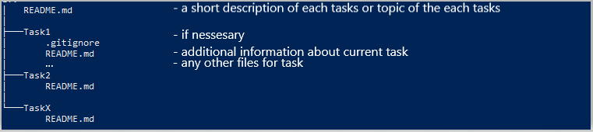

**EXTRA (optional)*:**

1. Read about GitHub Actions. What environment variables can be created?
2. Create your workflow, what consists of two jobs and contain requirements according the scheme below:

| Workflow variables should contain two variables:   1. ***DEPLOY_VER*** - should contains SHA; 2. ***YEAR*** - any year as you choose | |
| --- | --- |
| First job should:  Step should:   1. Print the list of files/directories in your github repository. 2. Print content of your log.txt file. 3. Print: “Hello from “*your* ***DEPLOY_VER*** *variable’s content***”** commit” | Second job should:   1. Run after the First job is finished. 2. Contain variable ***MONTH***- any month as you choose   Step should:   1. Contain variable ***DAY__OF_THE_MONTH*** - any day number as you choose. 2. Print the system date and time 3. Print your variable’s content:  “Day - “***DAY__OF_THE_MONTH***”;   Month - “ ***MONTH***”;  Year - “***YEAR***”.”   * Imagine that you keep in secret your favorite day of week (***FAVORITE_DAY_OF_WEEK***) and don’t want to share it with anyone. So where will you define it?   Print: “My favorite day of week is “content of ***FAVORITE_DAY_OF_WEEK***””  What result did you get and why? |